# Programming Fundamentals

**Lab Task#07:**

Question_01:

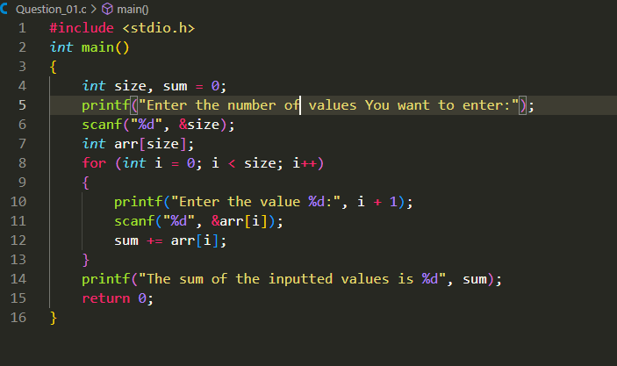

Question_02:

Question_03:

Question_04:

